**CSA1086 - Software Engineering**

Kanban Board

**Steps for Kanban Board**

**Step 1:** Create a Kanban Project

* Log in to Jira and click on Projects > Create Project.
* Choose Kanban Template and click Next.
* Name your project (e.g., "News Website Development") and configure the settings as needed.

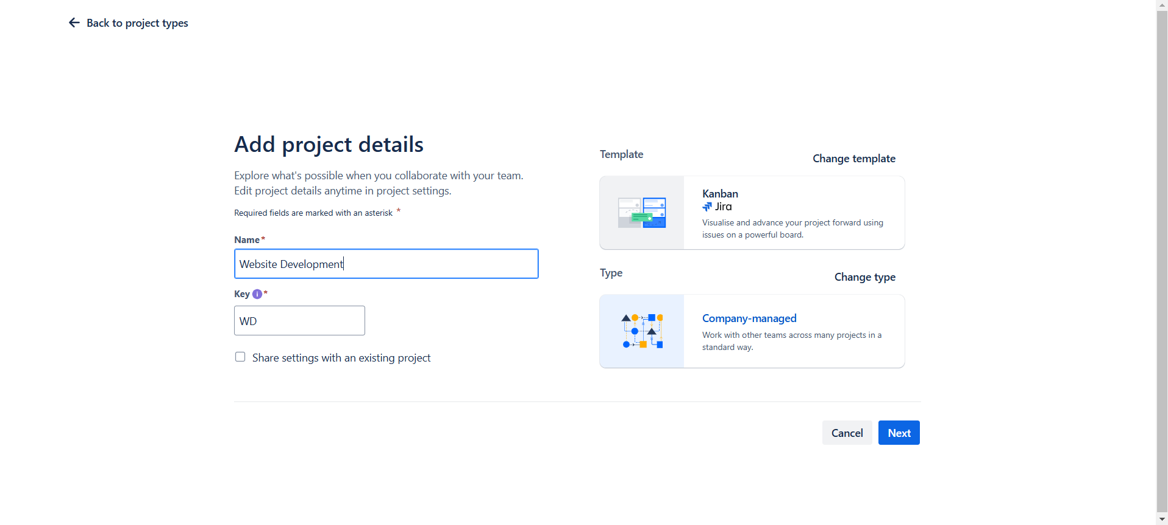

**Step 2:** Configure Kanban Board

* Navigate to the Board View from the left-side menu.
* Add columns that represent the workflow:
* Examples: To Do, In Progress, Review, Done.
* Customize column names by clicking the Board Settings > Columns.

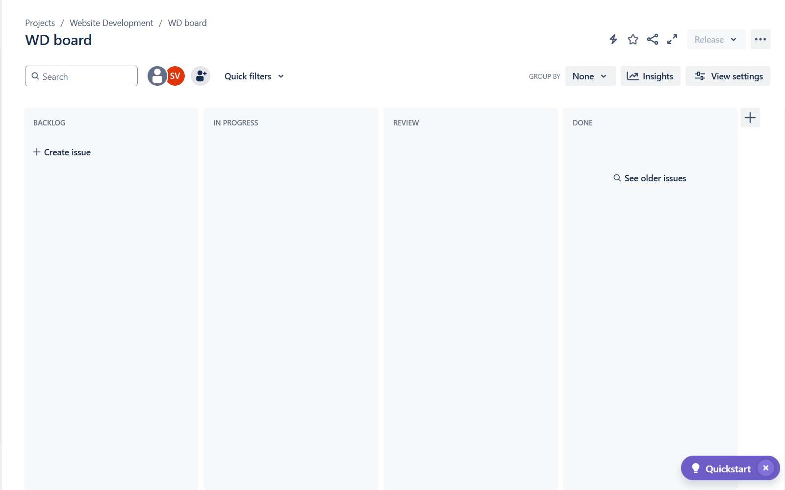

**Step 3:** Add Epics

* Go to the Backlog View and enable the Epic Panel (if not visible):
* Click on the three-dot menu ("...") > Show Epic Panel.
* Click + Create Epic in the Epic Panel.
* Fill in the details for each epic:
* Epic Name: Example: "Frontend Design" or "Backend Development".

**Summary:** A brief summary of the epic's goal.

**Description:** Add details on the epic’s objectives.

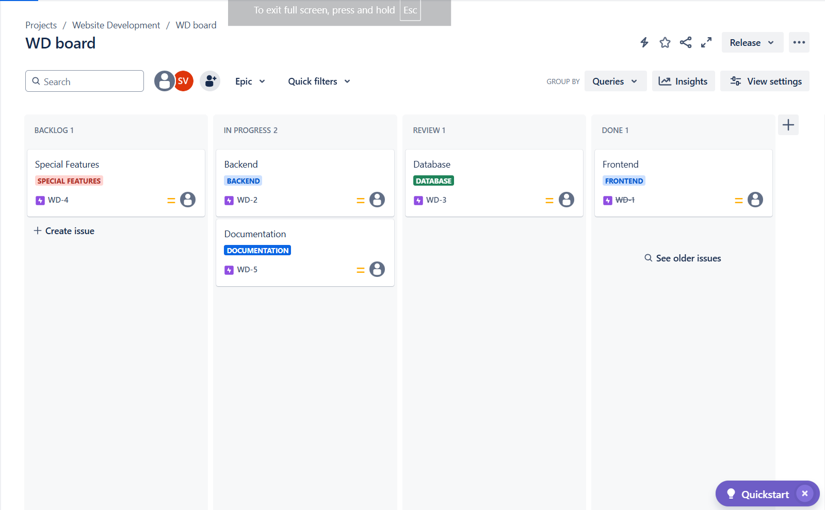

**Step 4:** Add Stories and Link to Epics

* In the Backlog View, click Create Issue and select Story as the issue type.
* Fill in the story details

**Summary:** Example: "Build the Website Structure."

**Description:** Add specific tasks to complete the story.

**Epic Link:** Link the story to its epic using the dropdown menu.

Save the story and repeat for all stories.

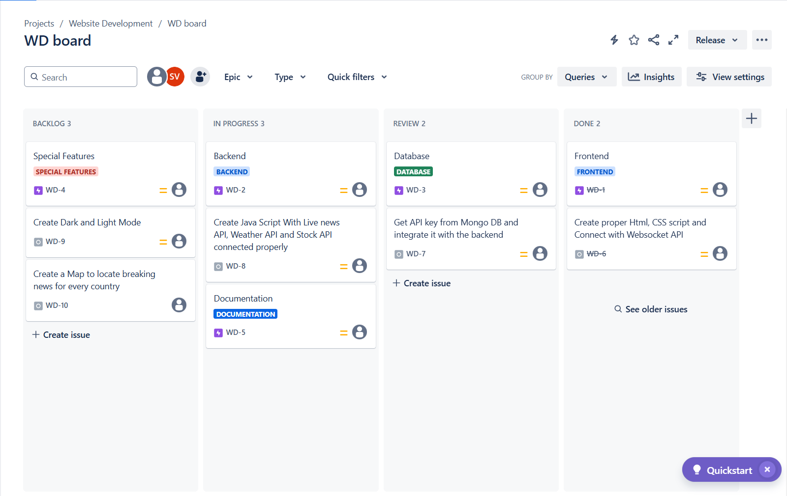

**Step 5:** Track Progress

* Drag stories from To Do to In Progress and finally to Done as they progress.
* Use the Cumulative Flow Diagram in Jira to monitor workflow efficiency.